Assisgnment-3 Satish Talluri
Q1.
- in this case I proceed ahead with normality assumptions, that
  - Unaffected and affected data values are individually normal, and so is the difference between them.
  - Random sampling is done from the actual population
  - There are not limits for the volumes in actual data. Ie. Normal variate can assume any value –inf to +inf in general.
  - That the two data sets unaff and aff are independent from each other.

- Difference will be normal. MLE is unaff_mean^ - aff_mean ^ , and its std error is sqrt(stddev_unaff^/n+ stddev_aff^2/n).

unaff <- c (1.94,1.44,1.56,1.58,2.06,1.66,1.75,1.77,1.78,1.92,1.25,1.93,2.04,1.62,2.08)
aff <-c (1.27,1.63,1.47,1.39,1.93,1.26,1.71,1.67,1.28,1.85,1.02,1.34,2.02,1.59,1.97)

# part a
# difference will be normal.

diff_estimate <- mean(unaff)-mean(aff)
diff_se <- sqrt ((((sd(unaff))^2) + ((sd(aff))^2))/length(unaff))

# 95% confid interval is

# since we are looking at magnitude, interval will be estimated mean and 97.5% estimate only.

cat ("95% confid interval is :",diff_estimate," ::", diff_estimate+(1.96* diff_se), "\n")

95% confid interval is : 0.1986667 :: 0.3943572

  - Analytically:: First normality can be tested using a Shapiro test, and since the data come from twins (natural pairing) and sample size is small, a paired-test might be more relevant. It is because one of the data sets might be dependent on the other due to natural pairing.
Shapiro-Wilk normality test

data: unaff - aff
W = 0.9044, p-value = 0.1113 ( So the data is not normal)
  - Graphically: Plotting individually and then the difference between the sets of data shows they might not be normal.
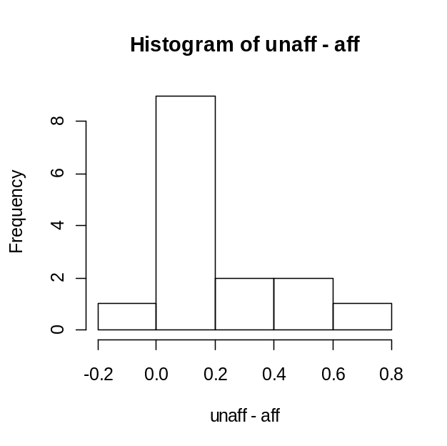
We can observe that the differences are not normal.
# graphically analyzing the normality of differences in volumes.
hist(unaff-aff,"FD")

# bootstrapping
diff_estimate_bt <- rep(0,1000)
order <- seq (1: length(unaff))

for (i in 1 : 1000) {
order_bt <- sample (order, replace=TRUE)

for (j in 1 : length(unaff)) {
unaff_bt <- unaff[order_bt[j]]
aff_bt <- aff[order_bt[j]]}

diff_estimate_bt[i] <- mean(unaff_bt)-mean(aff_bt)
#diff_se_bt <- sqrt ((((sd(unaff_bt))^2) + ((sd(aff_bt))^2))/length(unaff))
}

cat ("95% confid interval is :",quantile(diff_estimate_bt,.5) ," ::",quantile(diff_estimate_bt,.975), "\n")

Through bootstrap : 95% confid interval is : 0.11 :: 0.67

- Paired t-test
data: unaff and aff
t = 3.2289, df = 14, p-value = 0.006062
95 percent confidence interval:
0.0667041 0.3306292
mean of the differences 0.1986667

Q2 :
- Its given that samples are not random , it can be argued that a clustered sampling for either of the urban or rural areas, might lead to a bias, and can result in statistically significant differences in means/distributions. So t-test might not be totally applicable unless this random issue is fully resolved.
- CODE :
urban<-c(133,134,155,170,175,179,181,184,188,189,190,196,197,199,200,200,201,
201,204,205,205,205,206,214,217,222,222,227,227,228,234,234,236,239,
241,242,244,249,252,273,279,284,284,284,330)
ulen<-length(urban)
rural<-c(95,108,108,114,115,124,129,129,131,131,135,136,136,139,140,142,142,143,
143,144,144,145,145,148,152,152,155,157,158,158,162,165,166,171,172,173,
174,175,180,181,189,192,194,197,204,220,223,226,231)
rlen <- length(rural)
tlen <- ulen + rlen
seq <- c(urban,rural)

count <-0
perm <- rep (0, tlen)
t <- rep(0,10000)

abs_diff <- abs( mean(urban) - mean(rural))

for (i in 1: 10000) {
perm <- sample (seq, replace=F)

t[i] <- abs (mean(perm[1:ulen]) - mean(perm[(ulen+1):tlen]))

if (t[i] > abs_diff) { count <- count+1 }}
pval <- count/10000
cat ("mean diff", abs_diff,"\n")
cat ("pvalue :", pval,"\n")
Since p-value is 0 for a mean difference of ~ 59.8 , we can say that the difference is not statistically insignificant. So the urban and rural cholesterol levels do differ significantly.

Q3.
Simple plot shows that we might need a transformation. But I feel the graph is asymptotic to both x and y axes and might need log transformation on both axes. Here are the plots.
CODE :
x<-c(2.8,3.2,3.2,3.4,4.3,4.9,5.1,5.2,5.9,5.9,6.6,8.3,12.6,15.1,25.1,33.1,75.9,75.9)
y<-c(6.2,9,7.1,6.8,10.2,7.8,9.3,5.9,8.9,5.5,7.1,9.1,5.1,4.7,4.7,3.1,3.2,3.1)
plot(x,y)
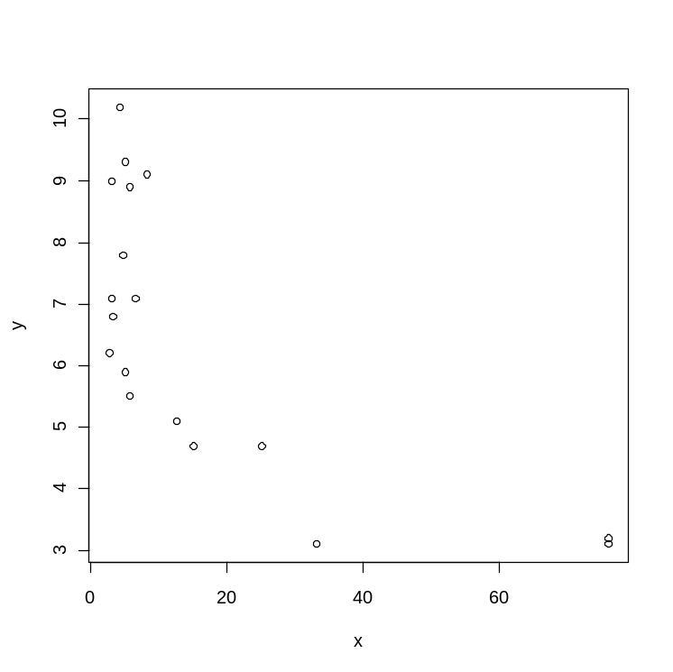

plot(log(x),y)
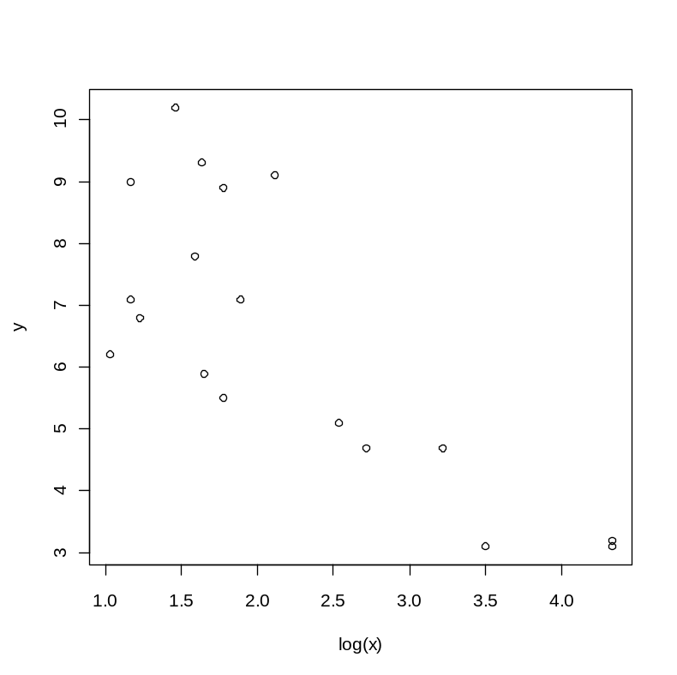
plot(x,log(y))
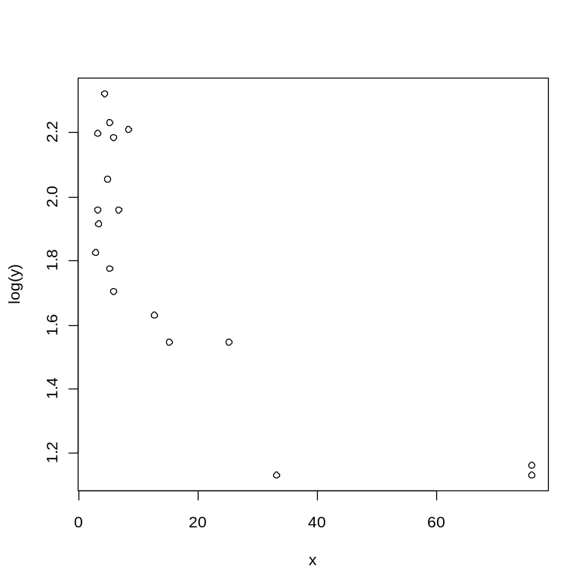
plot(log(x),log(y))
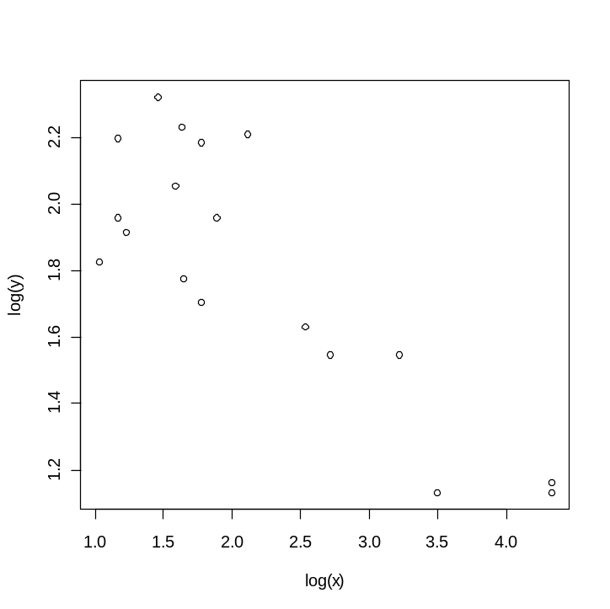
I will be comparing the linear regression between logx, and y and logx and logy, and depending upon the statistics, I will choose a better one.
- Simple linear regression
CODE :
# simple linear regression, using the code given by prof.Laha directly.
lmy<-lm(y~x)
summary(lm(y~x))
f<-fitted(lmy)
r<-resid(lmy)
r1<-r/sd(r)
hist(r1,"FD")
qqnorm(r)
plot(f,r)
cor(x,y)
abline(lm(x~y))
pred.frame<-data.frame(x=0:12)
pc<-predict(lmy,int="c",newdata=pred.frame)
pp<-predict(lmy,int="p",newdata=pred.frame)
plot(x,y,ylim=range(x,pp,na.rm=T))
pred.x<-pred.frame$x
matlines(pred.x,pc,lty=c(1,2,2),col="black")
matlines(pred.x,pp,lty=c(1,3,3),col="black")

Note : we can see that the correlation is -0.711 and R2 is 0.47 , F-stat is 16.36 on DF 16, with p-value = 0.0009392
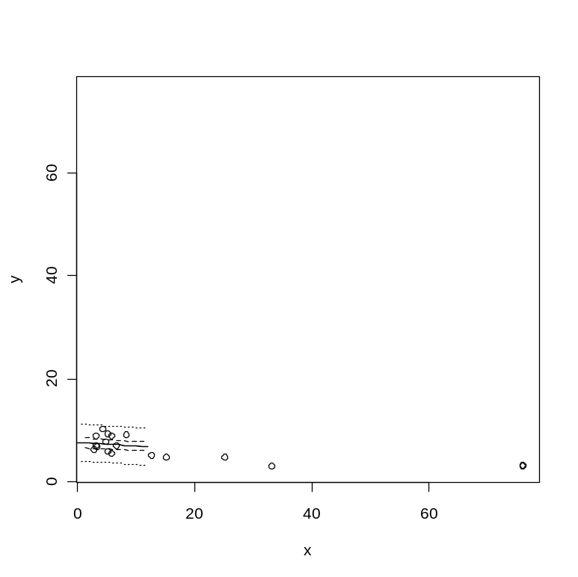
- Now doing regression for , log(x) vs y
Just changed x <- log(x) and rerun the above code.
Corr : -0.76, and the residual plot is as below
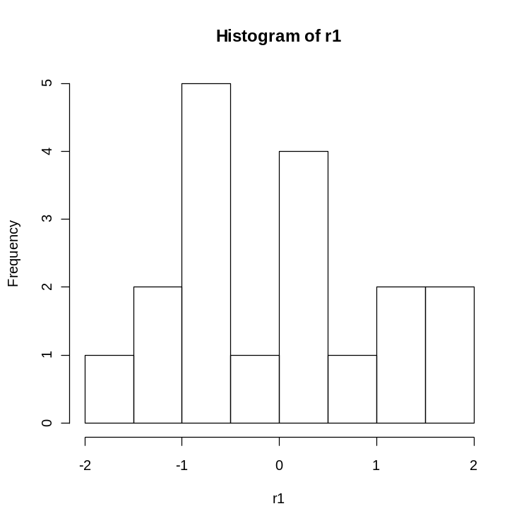
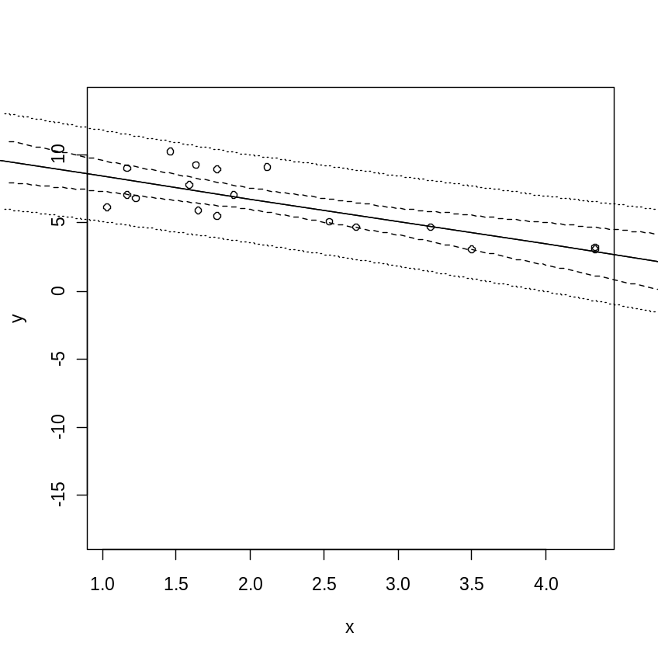
Note : we can see that the correlation is -0.711 and R2 is 0.5641 , F-stat is 23 on DF 16, with p-value = 0.0001978
- Now doing regression for , log(x) vs log(y); So in code just changed y<- log(y)

Residual plot :
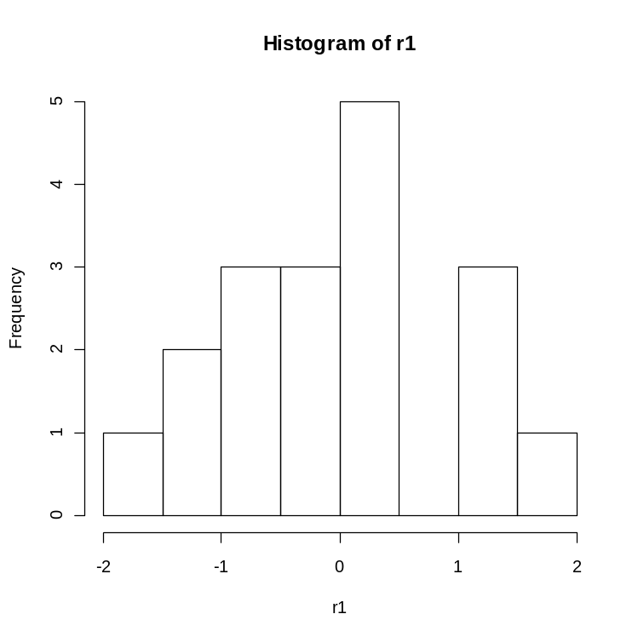

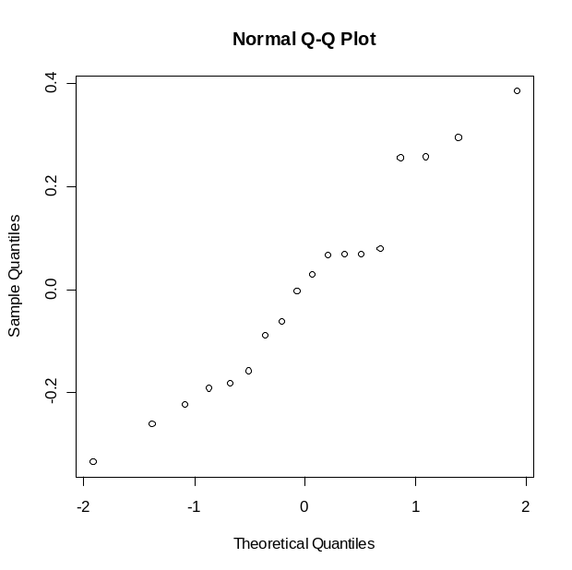
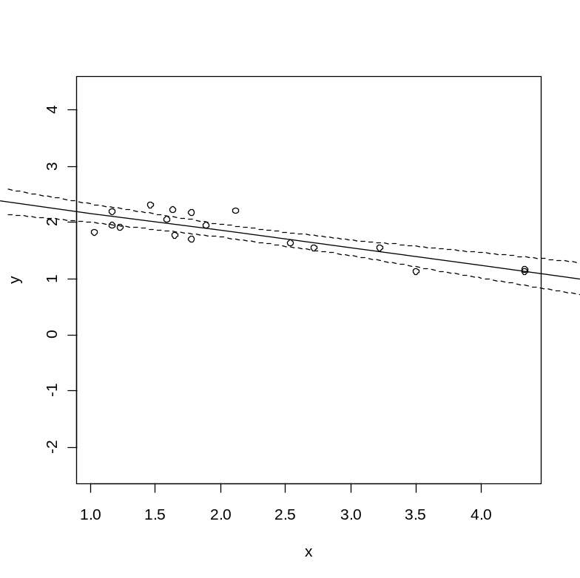
R-squared = 0.6941, F-stat : 39.57 on DF 16, p-value = 1.07e-5

In all even from the above plots log(x) and log(y) have a linear relationship.
- Theil-Sen’s estimator
Code :
# Theil-sens estimator
len <- length(x)
slope <- rep(0, (len)*((len-1)/2) )
count <- 0
for (i in 1 : len) {
for (j in 1 : len) {
if (j>i) {
count <- count +1

slope[count] <- (y[j]-y[i])/(x[j]-x[i])}} }
hist(slope,"FD")
cat ("Theil-Sen estimator::", median(slope),"\n")
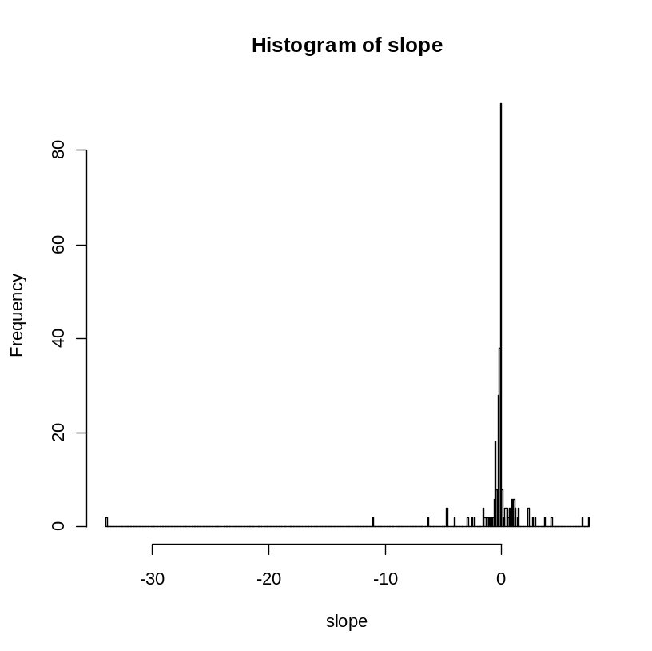
Earlier coeff : 7.63 and slope (-0.06) based on log x and log y, whereas thiel-sen’s gives -0.0975

Part © : I feel a logx vs log y regression is better, and so the log(wine consumption) and log(mortality %) are related in the following way
Log(y) = 2.47 -0.31 Log(x)

Q4 :
Hodges lehman estimator : (x+y)/2
CODE : urban<-c(133,134,155,170,175,179,181,184,188,189,190,196,197,199,200,200,201,
201,204,205,205,205,206,214,217,222,222,227,227,228,234,234,236,239,
241,242,244,249,252,273,279,284,284,284,330)
ulen<-length(urban)
rural<-c(95,108,108,114,115,124,129,129,131,131,135,136,136,139,140,142,142,143,
143,144,144,145,145,148,152,152,155,157,158,158,162,165,166,171,172,173,
174,175,180,181,189,192,194,197,204,220,223,226,231)
rlen <- length(rural)
tlen <- ulen + rlen
count <- 0
hbs <- rep(0, (ulen*(ulen-1)/2) )
for ( i in 1 : ulen) {
for ( j in 1 : ulen) {
if (j>i ) { count <- count +1
hbs[count] <- (urban[i] + urban[j] )/2 }} }
hbs_urban_estimator <- median(hbs)
cat ("hbs urban estimator:", hbs_urban_estimator,"\n")
count <- 0
hbs <- rep(0, (ulen*(ulen-1)/2) )
for ( i in 1 : rlen) {
for ( j in 1 : rlen) {
if (j>i ) { count <- count +1
hbs[count] <- (rural[i] + rural[j] )/2 }} }
hbs_rural_estimator <- median(hbs)
cat ("hbs urban estimator:", hbs_rural_estimator,"\n")

cat (" difference :", hbs_urban_estimator -hbs_rural_estimator,"\n")
# part b : hubers estimator; Load MASS package
huber(urban)
# bootstrapping to find 95% confidence interval for Huber and hodges-lehmann estimator
perm <- rep (0, ulen)
hbr_bt <- rep(0,10000)
hdl_bt <- rep(0,10000)
for (i in 1: 10000) {
perm <- sample (urban, replace=T)
# calculating the huber's estimator as above or write a function for it and use it here and do bootstrap
#hbr_bt [i] <- huber(perm)
# hodges -lehmann
count <- 0
hbs <- rep(0, (ulen*(ulen-1)/2) )
for ( k in 1 : ulen) {
for ( j in 1 : ulen) {
if (j>k ) { count <- count +1
hbs[count] <- (perm[k] + perm[j] )/2 }} }
hdl_bt[i] <- median(hbs)}
cat ("95% confid interval of hodges-lehmann :", quantile(hdl_bt,.025),"::",quantile(hdl_bt,.975),"\n")
cat ("95% confid interval of huber :", quantile(hbr_bt,.025),"::",quantile(hbr_bt,.975),"\n")

